A
Assignments
of
Procedural Programming Fundamental Using C Language
Bachelor of Computer Application – I Sem


RUNGTA INTERNATIONAL SKILLS UNIVERSITY
SESSION: 2025-26

MR. Shivansh Mehta Submitted by :-
(lecturer) Angel B M
Ref No-2025/00745
ERP ID – RU-25-10189

Submitted To:
RUNGTA INTERNATIONAL SKILLS UNIVERSITY,
CG
SCHOOL OF INFORMATION TECHNOLOGY

S.NO | PROGRAM NAME | Page No | Remarks
1 | Aim-1- Setup VS code + GCC ,Write first C program , Explain structure, Printf statements
2 | Aim-2 -Draw Flowcharts for sum & largest of two numbers , implement the program in C, show VS code shortcuts any 5
3 | Aim -3- declare variables if int ,float , char , double ; scanf/printf with format specifiers, swap numbers
4 | Aim-4 Odd/Even check using if-else, max of three numbers (nested if), Ternary operator, switch-case calculator
INDEX

Aim 1 : Setup VS code + GCC Write first C program ,explain structure ,print name /age using printf statement :

Here are the steps to setup vs code + GCC Compiler :-
- Step 1 - Install VS Code
- Step 2 - Install GCC Compiler
- Step 3 – check GCC installed or not and gine command
- Step 4 - setup in VS code
- Step 5- Run the program

Explanation of structure :
- #include <stdio.h> is a header file for input /output functions
- main( ) - Program starts from here
- printf( ) – it is used to print text
- return 0 ; - Ends the program successfully
Input :
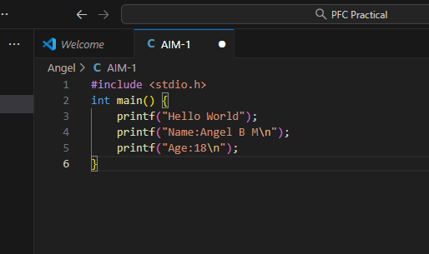
Output :
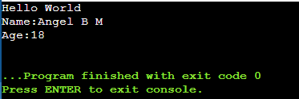
Aim 2 – Draw flowcharts for sum and largest of two numbers , implement the program in C ,Show VS Code shortcuts any 5

Flowchart :
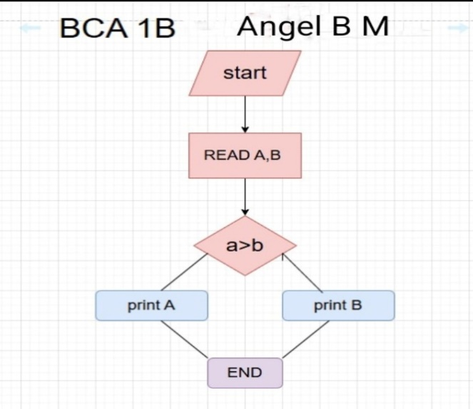

Input :
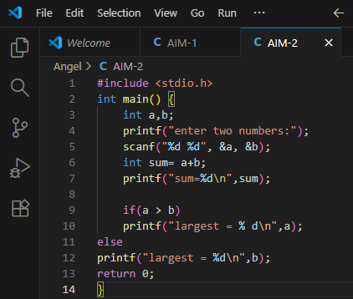

Output :
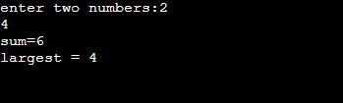
Five Shortcuts for VS Code :
- Ctrl + S - It saves the file
- Ctrl + Z - Used to undo
- Ctrl + / - Used for comment line
- Ctrl + C – Used to copy
- Ctrl + V – Used to paste

Aim 3: Declare variables of int, float, char , double , scanf /printf with format specifiers , swap numbers
Input :

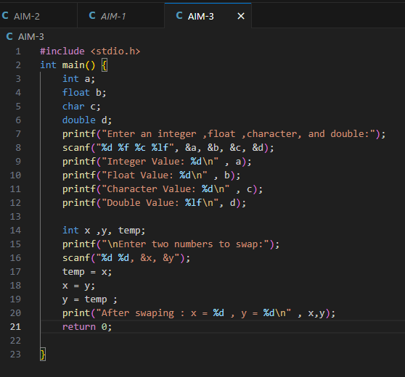
Output:
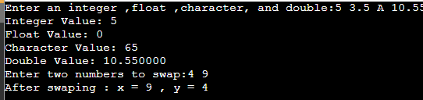

Aim 4 : Odd/Even check using if- else, Max of three numbers (nested if),
Ternary operator, Switch case calculator
Input: Finding even/odd
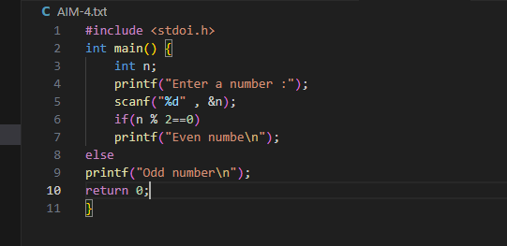

Output :

Maximum of three numbers (nested if)
Input :
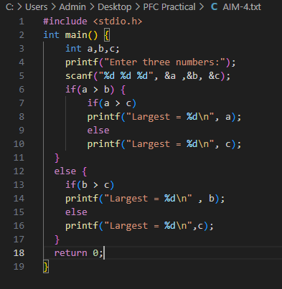

Output :
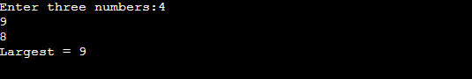

Ternary operator example
Input :
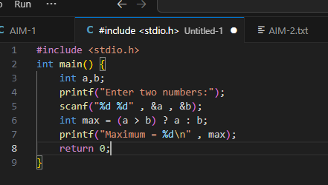

Switch-case Calculator: Input: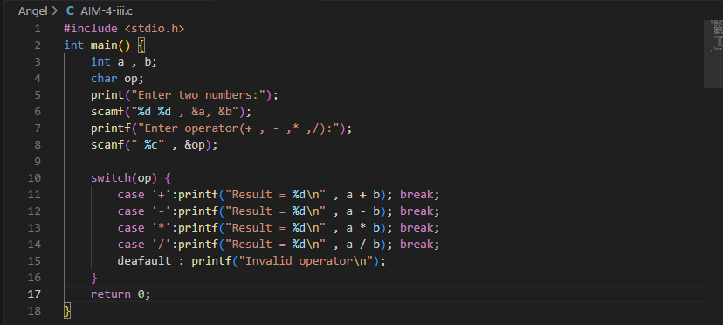
Output :
